# 1. Overview

This document provides a detailed breakdown of the architectural components and design principles behind the NAO Dance Analyzer. The system is designed to enable a NAO robot to process and interpret musical input, analyze its properties, and execute a dance routine that best reflects the mood and energy of the song. The system incorporates audio analysis, choreography generation, and robotic execution to form an adaptive and expressive dance system.

The primary objectives of this project are:

* To develop a robust audio analysis module capable of extracting key musical features.
* To implement a sophisticated choreography selection system that adapts movements based on song attributes.
* To establish a seamless communication protocol between the processing units and the NAO robot’s movements.
* To provide an user interface that allows users to input or select songs and observe the dance performance in real time.

# 2. High-Level Architecture

The system follows a layered approach where different modules handle distinct aspects of the dance generation process. This modular structure ensures that enhancements or modifications can be made without affecting the core functionality of the system.

## 2.1. Audio Analysis Module

* The audio analysis module is responsible for breaking down the musical input into fundamental components such as tempo (beats per minute), key, and emotional tone.
* Feature extraction includes rhythm detection, beat mapping, and spectral analysis to determine the energy and mood of the song.
* The analyzed data is then formatted into a structured dataset that serves as input for the choreography generation module.

## 2.2. Dance Generation Module

* The dance generation module translates the extracted musical features into a structured set of movements.
* A rule-based system initially maps music attributes to predefined dance sequences.
* Machine learning techniques may be employed to refine and personalize dance movements over time, ensuring a more dynamic and responsive system.
* A choreography database contains a diverse range of movements, categorized by energy level, mood, and tempo.
* Smooth transitions between movements are managed by a sequence optimization algorithm to maintain natural fluidity in the dance performance.

## 2.3. Robot Control Module

* The robot control module interfaces with the NAO robot to execute the selected dance moves.
* It converts predefined movements into low-level control commands compatible with the NAO’s motor functions.
* Real-time synchronization is achieved through precise timing adjustments to align dance movements with the beats of the song.
* This module also incorporates an error-handling system to detect and adjust any movement discrepancies to avoid robotic imbalance or misalignment.

## 2.4. User Interface

* A web-based or mobile application allows users to interact with the system by selecting songs and initiating dance routines.
* The interface provides real-time feedback on the analyzed song attributes, including BPM, mood, and key.
* It features controls for adjusting choreography preferences and observing live updates on the dance execution.

# 3. Component Descriptions

## 3.1. Audio Analysis

* This module serves as the foundation for the entire system, as the accuracy of musical interpretation directly affects the quality of dance performance.
* It is designed to handle multiple genres and dynamically adjust for varying song structures.
* The data processing pipeline includes noise filtering, tempo extraction, and mood classification to ensure optimal feature extraction.

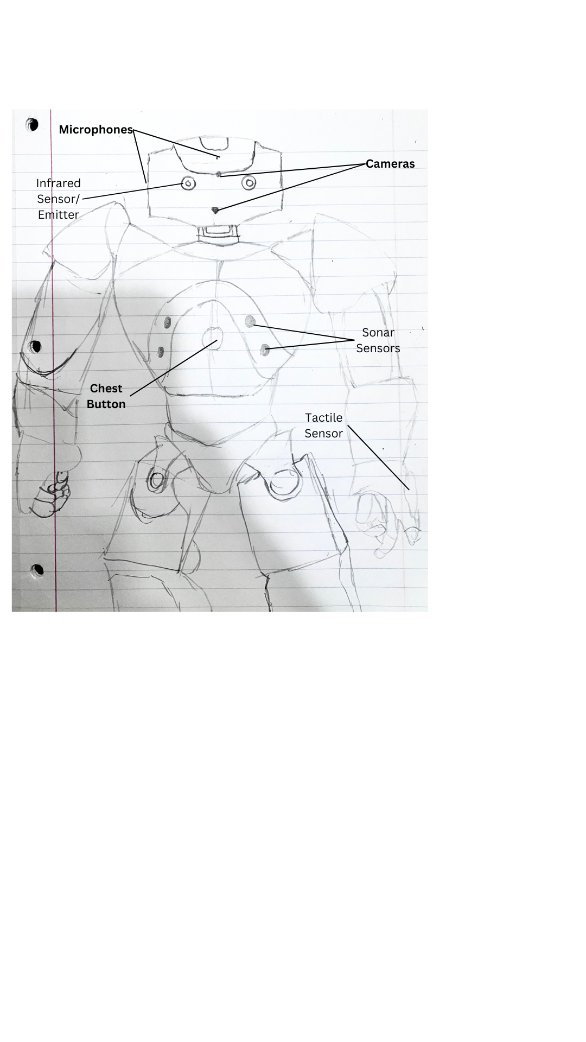

##### *Figure 1: A diagram of all the sensory devices on the NAO robot. Sensors relevant to sign analysis in bold*

## 3.2. Dance Generation

* This module is responsible for choreographing expressive and engaging dance routines.
* The movement selection process is guided by predefined dance categories that match different musical styles.
* Each dance sequence is tagged with attributes like speed, intensity, and fluidity to ensure a seamless match with the extracted song data.
* Over time, the system learns and refines movement selections based on user feedback and iterative performance evaluations.

## 3.3. Robot Control

* This module is responsible for ensuring precise execution of dance movements by translating high-level choreography into NAO-compatible motor commands.
* The NAO robot's degrees of freedom are carefully controlled to maintain balance and hardware safety in its dance.
* Calibration functions adjust for discrepancies in execution, ensuring smooth and reliable performances.

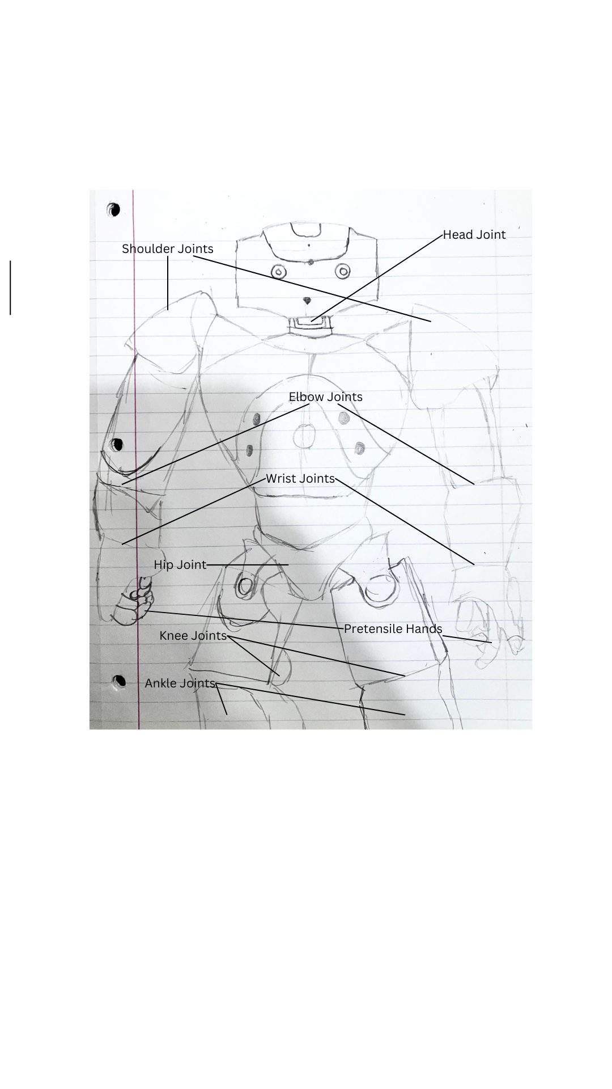

##### *Figure 2: A diagram of all movement joints on the NAO robot*

# 4. Data Flow

1. User selects or uploads a song via the interactive interface.
2. The audio analysis module processes the song and extracts key musical features.
3. The dance generation module interprets the extracted features and selects appropriate dance movements.
4. The robot control module translates the selected movements into executable commands.
5. The NAO robot performs the dance routine in synchronization with the song.

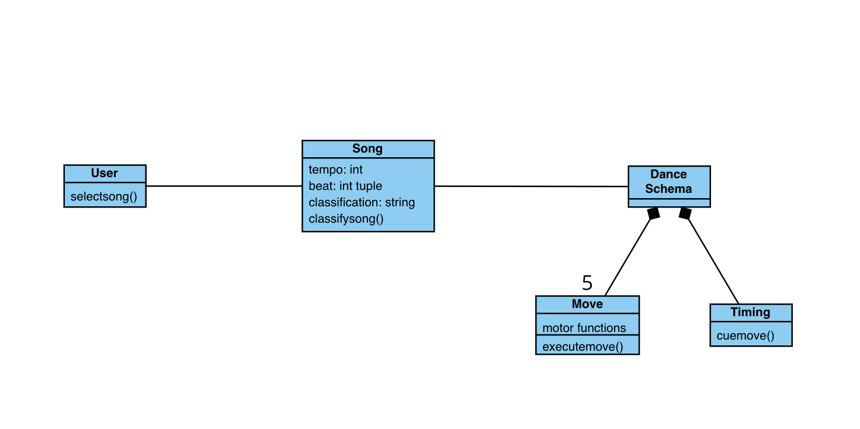

##### Figure 3: Class Diagram displaying the data flow for creating dance schemas

# 5. Key Architectural Decisions

## 5.1. Performance Optimization

* To ensure low latency, song analysis is conducted in parallel with movement selection.
* Precomputed choreography templates speed up the dance generation process.
* Efficient data handling techniques prevent bottlenecks during real-time execution.

## 5.2. Scalability

* The modular architecture allows for easy expansion of the dance library.
* Additional robot models can be integrated with minimal modification to the control module.
* Future updates may include user-customized choreography based on personal preferences.

## 5.3. Security Considerations

* Secure authentication is implemented for user interactions with the system.
* API requests for external audio analysis services may be encrypted (if at all needed) to prevent unauthorized access.
* Robot control commands include safety measures to prevent erratic behavior or unintended movements.

# 6. Conclusion

The NAO Dance Analyzer represents a fusion of music analysis and robotics, constructing a platform that seamlessly blends technology and artistic expression. By leveraging various audio processing techniques, musical theory, and dynamic choreography generation, this system enables a NAO robot to engage with music in an expressive and personalized way. The architecture is designed to ensure scalability, efficiency, and adaptability, allowing for future potential development.